Name: Hossein Gerami

Bachelor: Electronic

Master of: Industrial Management

Address: University of Science and Industry

Birthday: 1994   May 24, Tuesday

WhatsApp: +989358774584

LinkedIn**:** [**linkedin.com/in/hossein-gerami-6bb89a168**](https://www.linkedin.com/in/hossein-gerami-6bb89a168)

**Who am I?**

I've worked in software engineering for my entire 10-year career, and my commitment to critical thinking and attention to detail have gotten me to where I am today: a senior software engineer for First Technology.

I am able to handle multiple tasks on a daily basis.

I use a creative approach to problem solve.

I am always energetic and eager to learn new skills.

I have experience working as part of a team and individually.

I am flexible in my working hours, being able to work evenings and weekends.

I am honest and trustworthy when I am counting money after our church bake-sales.

I am motivated to go to the gym before work to get fit and healthy.

“Prior to my senior role, I worked as a software engineer for First Technology and a programmer for Mobile First (React Native).

Because I've already held all the other positions in this field,

I have keen insight into what it takes to run a successful project.

**Skills**

React

Redux

React Native

Nodejs

Express JS

Feathers JS

Python (flask library)

Mongo dB

Html

CSS

Sass

WordPress

WooCommerce

jQuery

Bootstrap

Photoshop

illustrator

**Portfolios**

Gardenia

Gardenia is an application that can control 2 kinds of IOT devices, by Bluetooth and WIFI. also, it has a shop to by these devices, and a notification management.

Gardenia is an English company that make hood and sanitizer and also freshener.

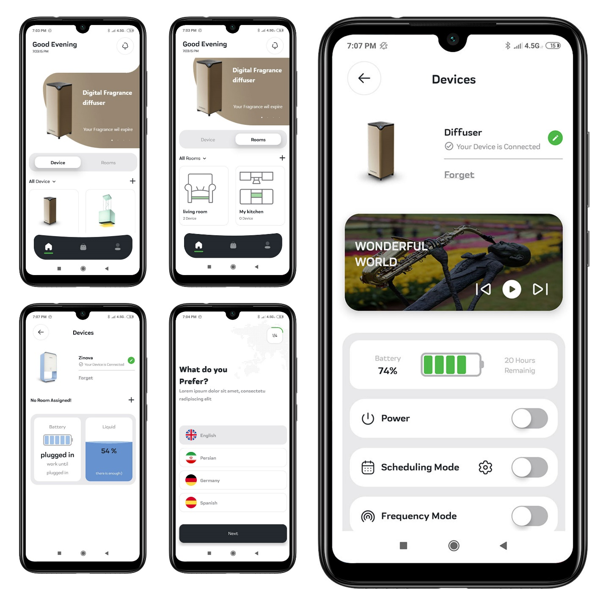

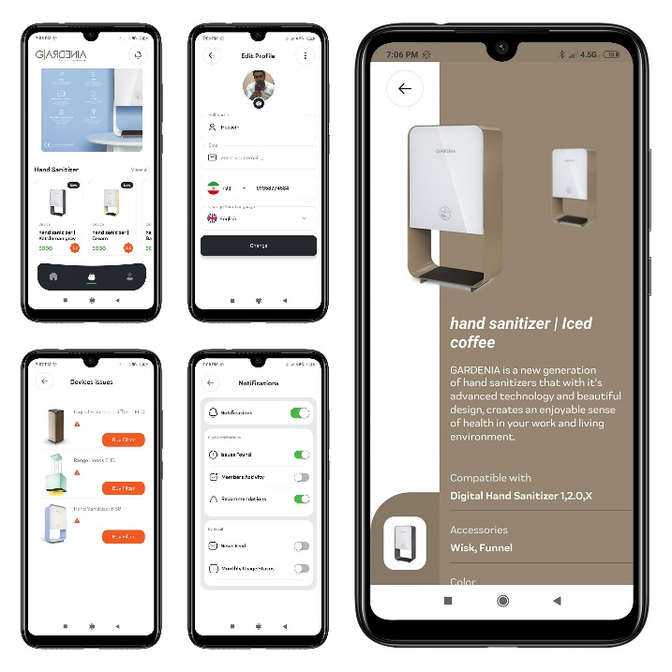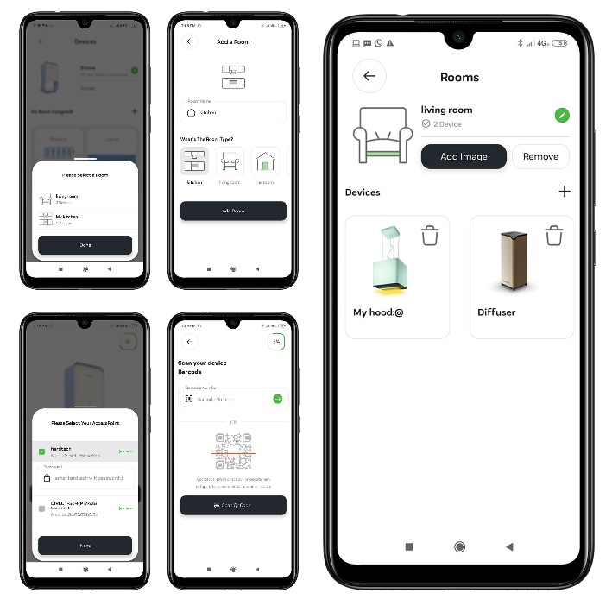

Quick Claim

Both qc card and qc pay has built for a NDIS management system in Australia.

this is an end-to-end software solution, with customizable workflows, to automate clients NDIS claiming.

this system lets you access live cashflow visibility through instant NDIS API integration.

Qc card:

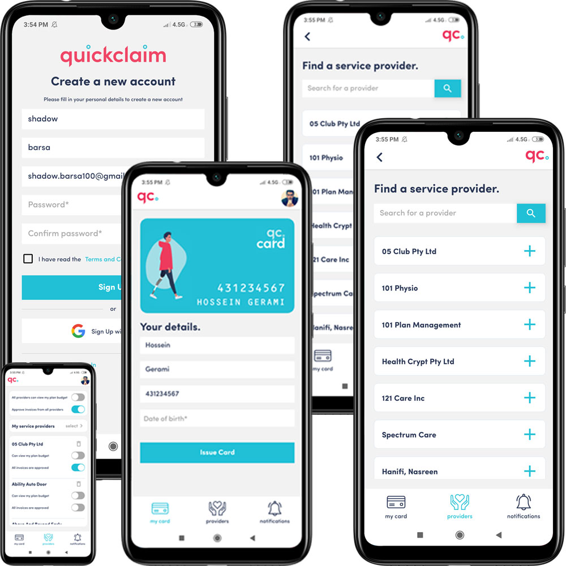

Qc pay:

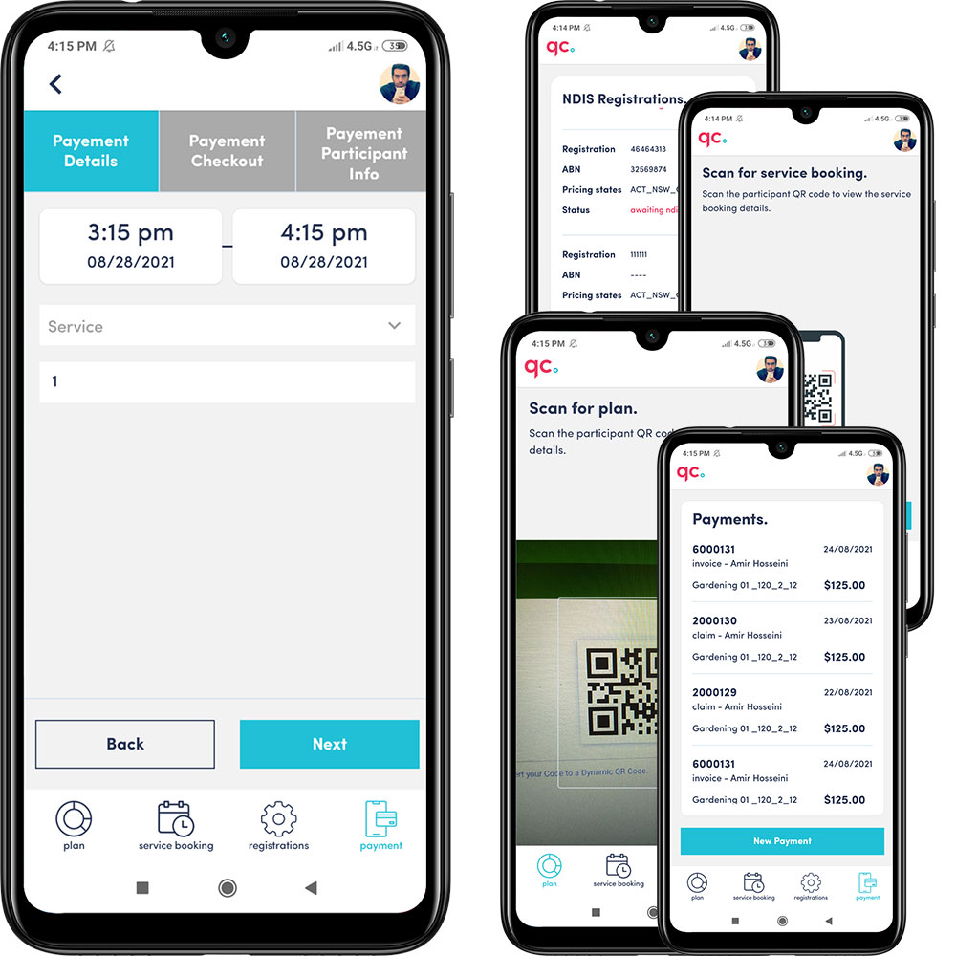

Lerne24

Lerne24 is a learning management application for android and IOS platform, that can learn 2 German language and French language.

Lerne24 has a friendly interface that's encouraging and attractive.

You can start with the most common words where you earn points for selecting the correct word missing from the sentence.

it has made by ionic-react and typescript.

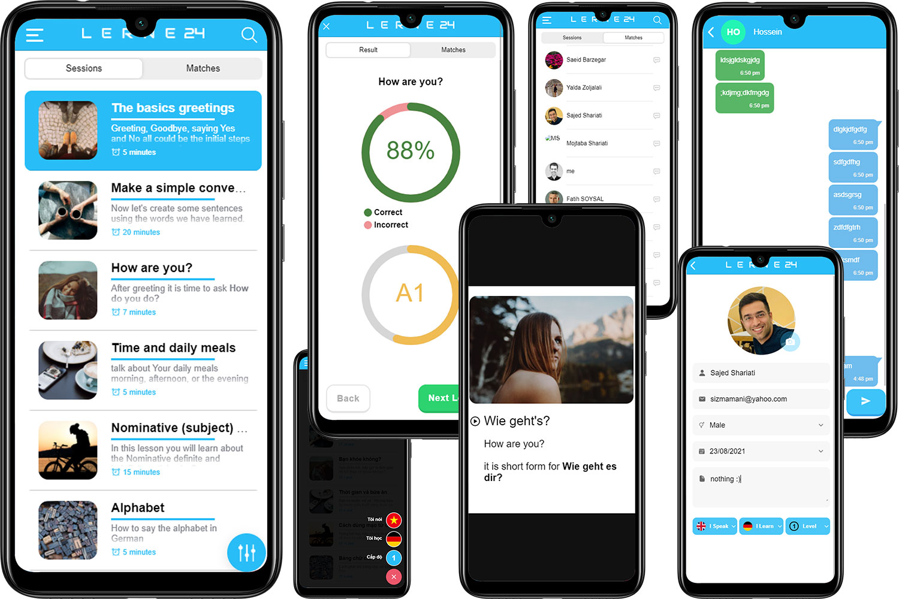

Hihab

Hihab is a habit tracker application for both android and IOS platform. It supports both Persian and English language.

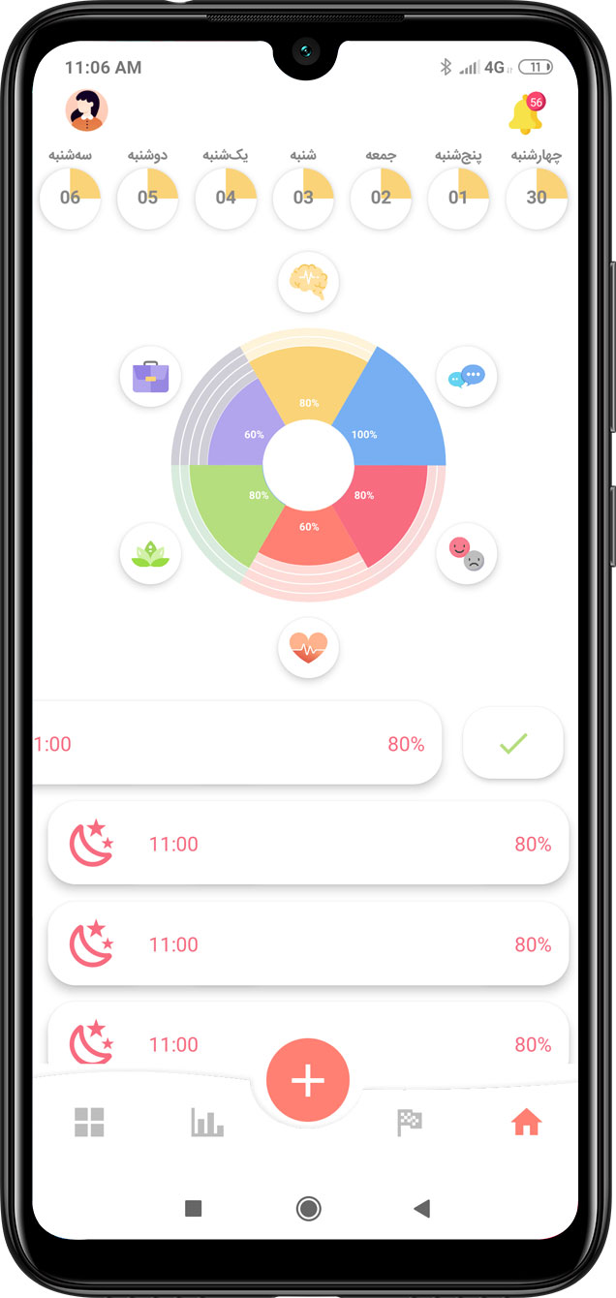 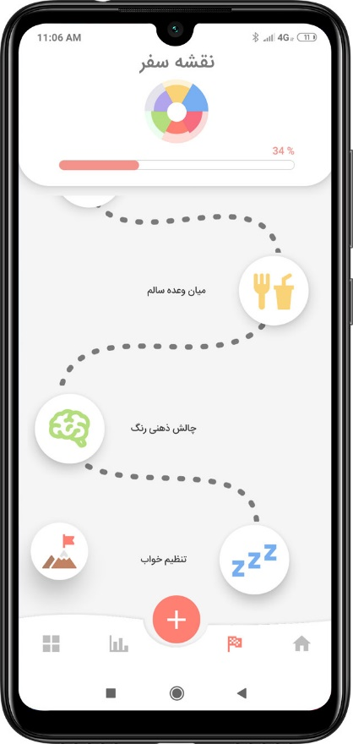 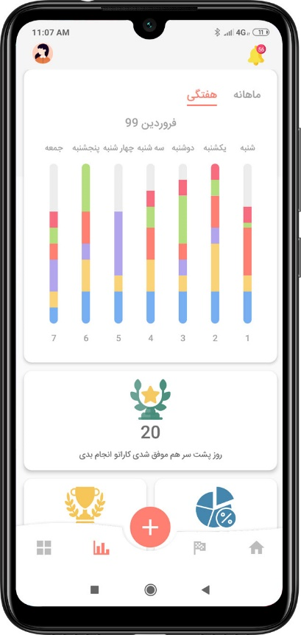

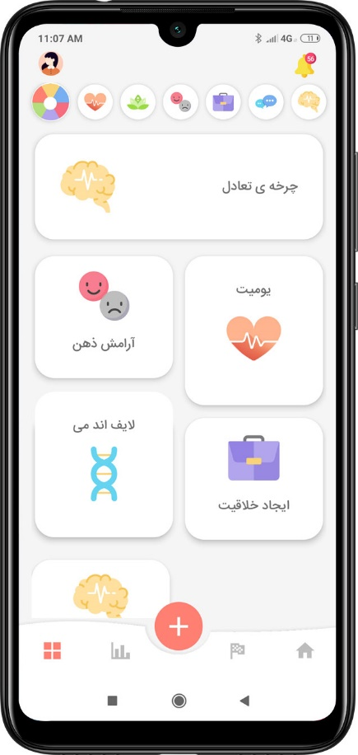 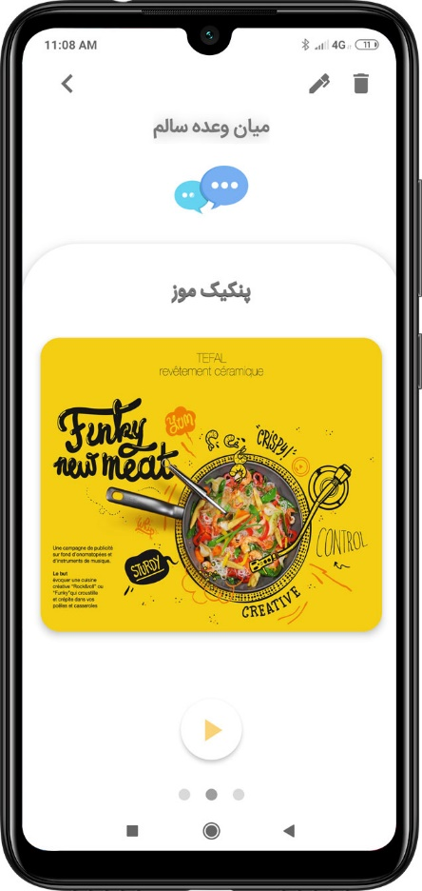 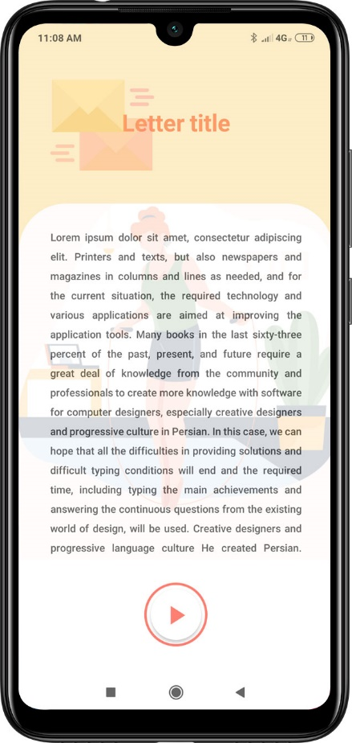

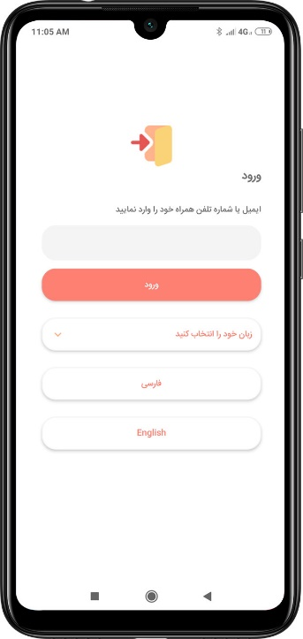 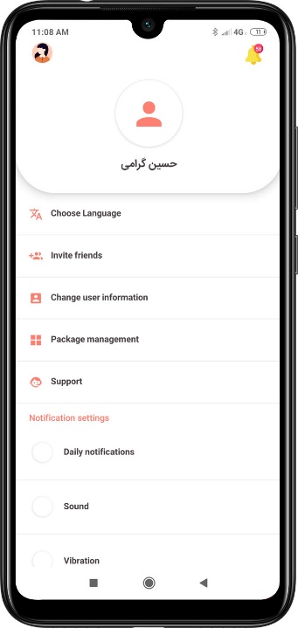 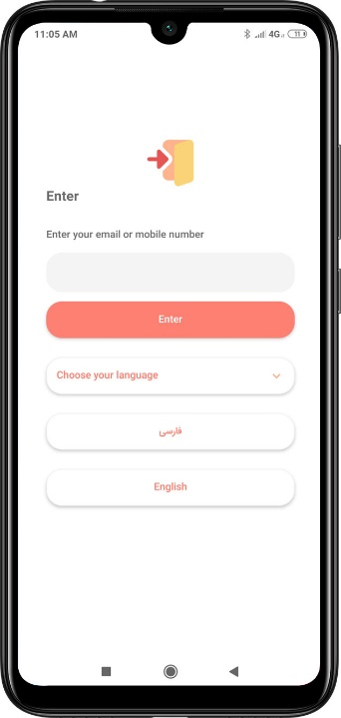 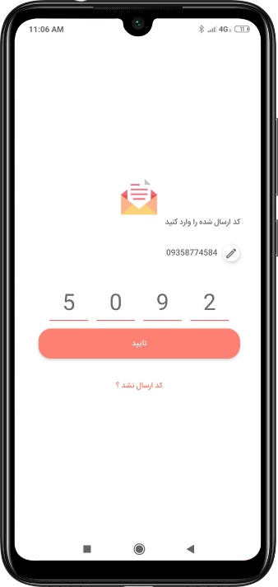

HoomQC

HoomQc is an In-house application to test all kind of Smarthoom Company IOT Devices by Bluetooth.

for example, we can test the signal strength of devices by sending and receiving command to them with Bluetooth protocol.

